**Major Problem Pharma Industry faces today:**

* **Proliferation of Counterfeit Drugs:**

One in 10 drugs sold in Bangladesh is counterfeit, leading to hundreds of deaths per year. This causes great loss of money and brand-goodwill for the pharmaceutical companies.

* **Chain Inefficiencies**

Since each participant in the pharmaceutical distribution process uses different IT systems and ERP solutions, there are significant supply chain inefficiencies . This non-interoperability leads to lack of transparency and leakage points in the supply chain.

Currently there is very limited to no scope to track, trace the origin, authenticity and distribution of drugs.

**The TraceX platform:**

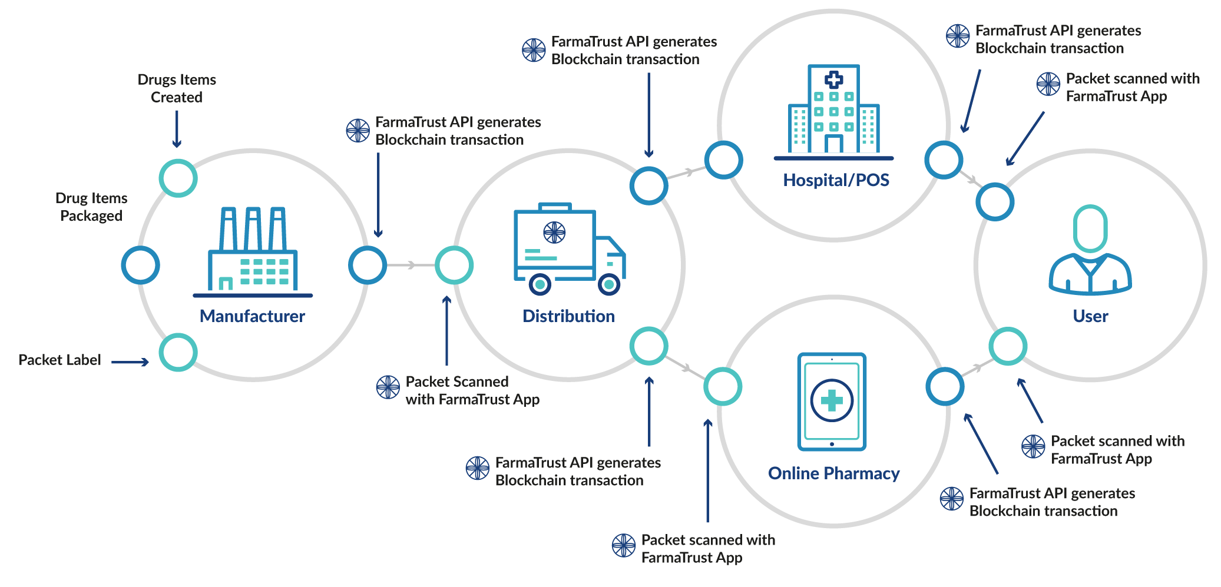

For solving the above mentioned problems we need to track pharmaceuticals through a supply chain that links digital systems to pharmaceuticals moving in the physical world. We help the manufacturers to put a qr code with serialization, in the drug- that uniquely identifies a drug. Our solution integrates to the manufacturers, warehouses, logistic-companies and pharmacies. From when a drug is produced, to whenever the drug changes its hand, its ownership information is added and updated in our blockchain network. So, when anyone wants to check the validity of the drug, only a qr-code scan by our app shows him all the distribution-points the drug has been to . This confirms the authenticity and origin of the drug- making sure it was produced by a trusted pharmaceutical.   
  
**Why adopt to TraceX platform?**  
Our platform TraceX is a distributed and interoperable pharmaceutical supply chain platform that leverages Blockchain as the underlying technology. The platform will:

* Provide pharmaceutical companies, their packagers, distributors, pharmacies and regulators the visibility needed to make critical decisions that can greatly reduce supply chain inefficiencies & costs;
* Protect consumers and brand through reduction of fake pharmaceuticals that make their way into the supply chain.
* Help prove the compliance of a drug, by ensuring its originality through track & trace. This will greatly help in pharmaceutical exports in Europe & US- where track & trace is being made mandatory by 2021